PROJECT-REPORT

* UNLOCKING INSIGHTS INTO THE GLOBAL AIR

TRANSPORTATION NETWORK WITH

TABLEAU

*Team ID -(NM2023TMID06289)

*Team Members:

K.GuruPrasad:(asunm1319222104925)

M.Ariyudainambi:(asunm1319222104915)

1. ArulKumar:(asunm1319222104916)

S.Ayyanar:(asunm1319222104917)

INTRODUCTION:

* 1. Overview:

* Air transport is one of the fastest modes of public transport which connects international boundaries. Air transport allows people from different countries to cross international boundaries and travel other countries for personal, business, medical, and tourism purposes.

* 1. Purpose:

* Air transport allows people from different countries to cross international boundaries and travel other countries foe personal,medical,and tourism purposes.

1. Problem Definition& Design Thinking:

* 1. EMPATHY MAP:

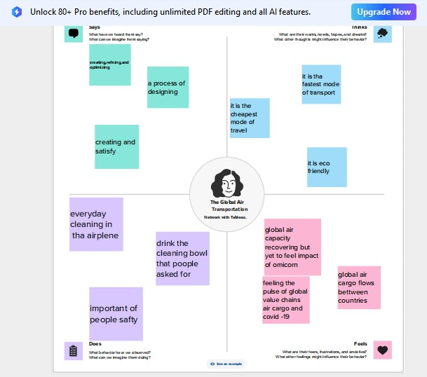

2.2:BRAINSTORME:

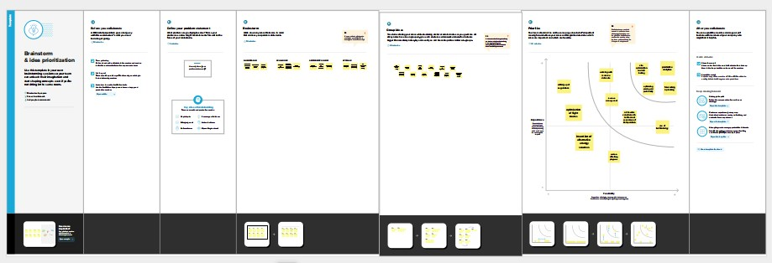

1. Result:

Using tableau software we analyzed the dateset of The Global Air Transportation Network.

*) World map showing detail of all airports within a country:

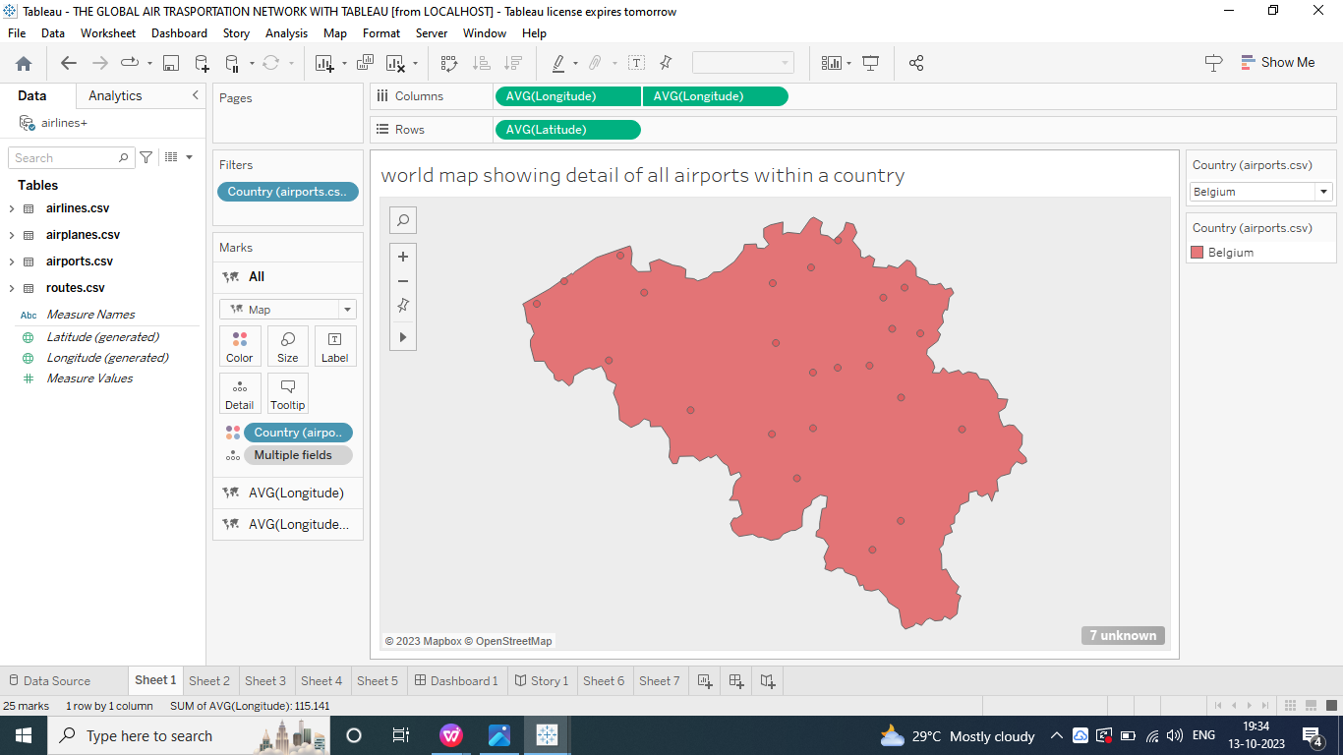

* Airports At Higher Altitude In The World :

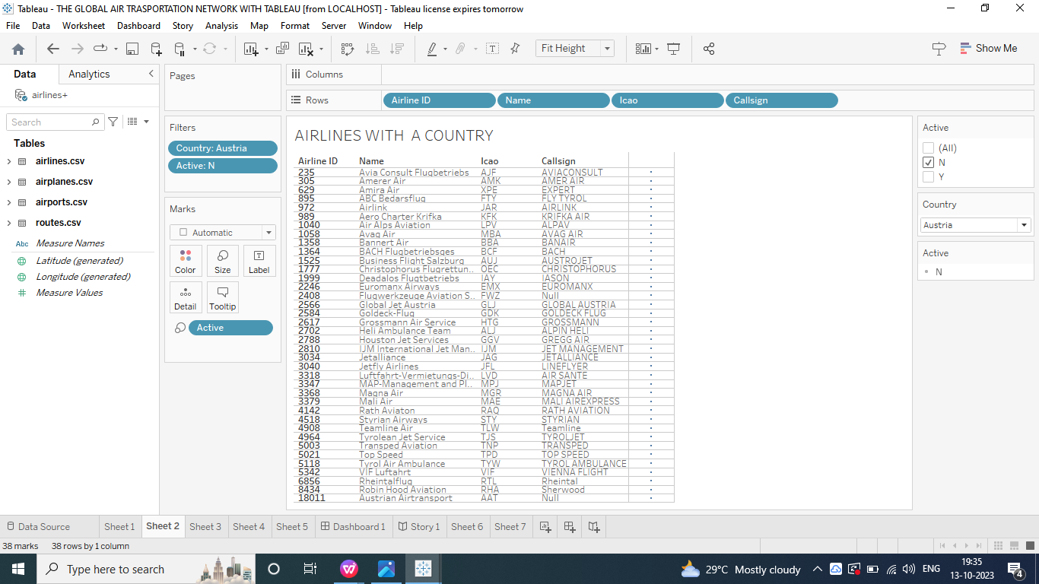

* Numbers of Flights From Airports:

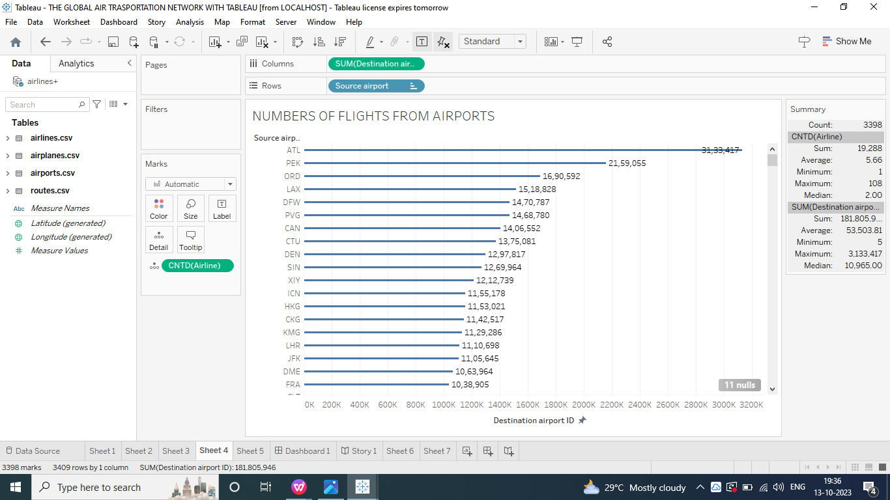

*Airlines With A Country:

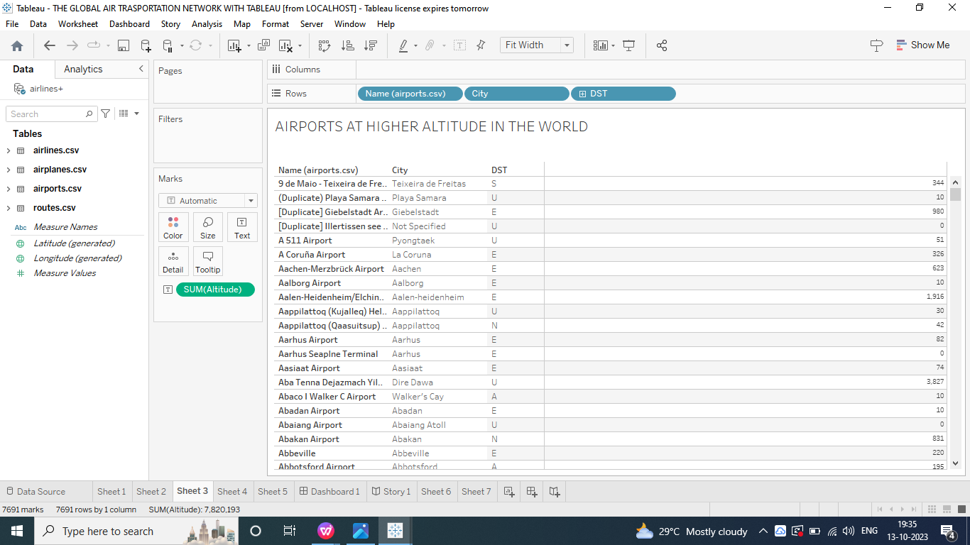

*Airports Of Airports With in A Country:

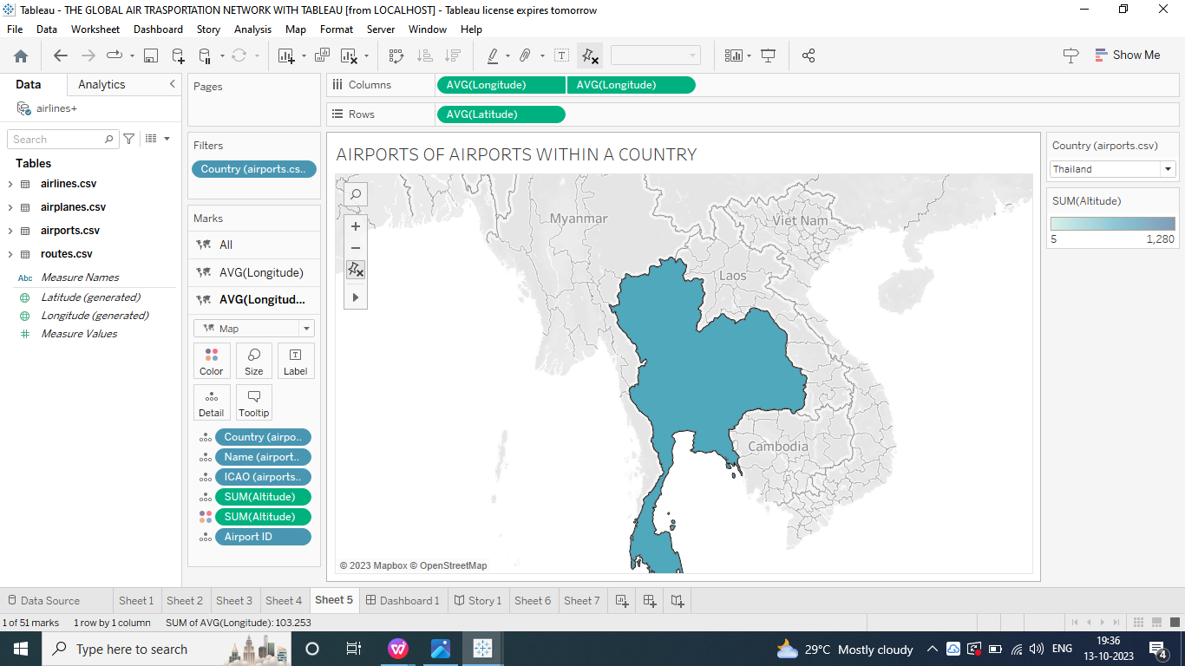

4.DASHBOARD:

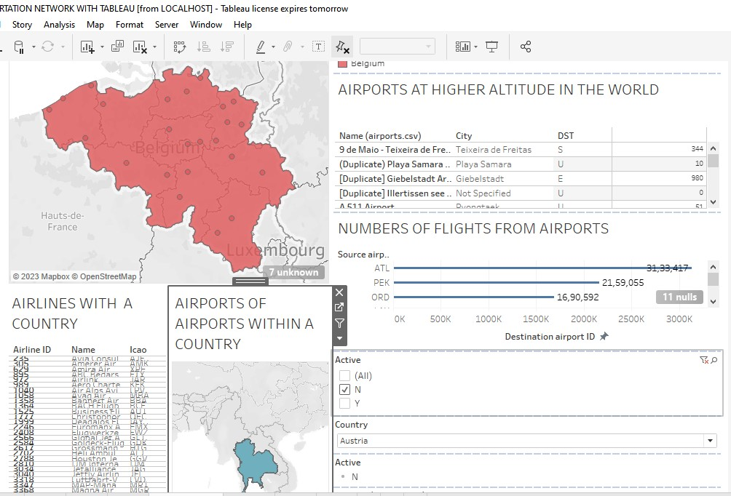

5.STORY:

1. Revolution:A Data Driven Exploration of Global of Air Transportation the world.

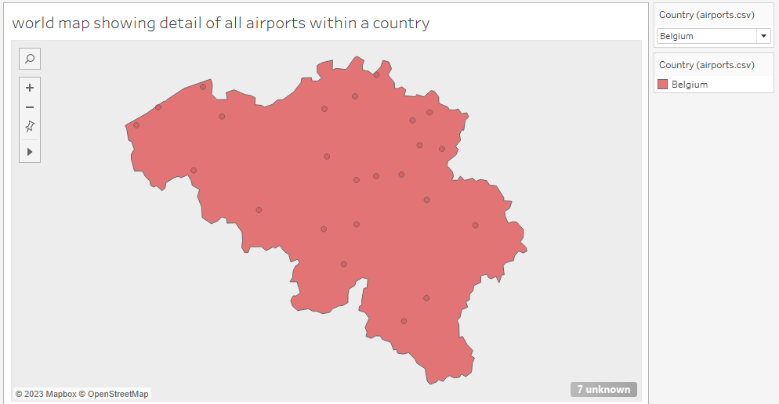

1. Revolution:A Date Driven Exploration of Global of Air Transportation the World.

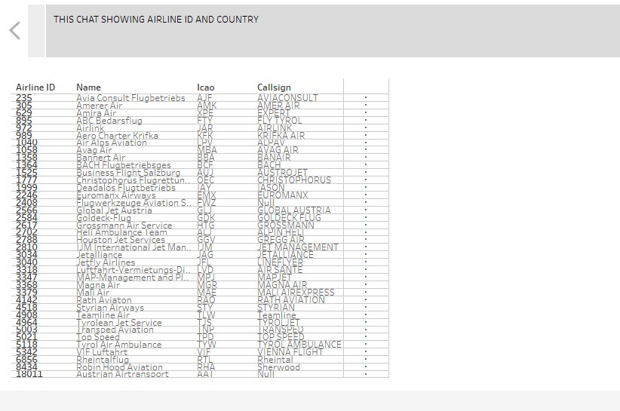

1. Revolution: A Data Driven Exploration of Global of Air Transportation the would.

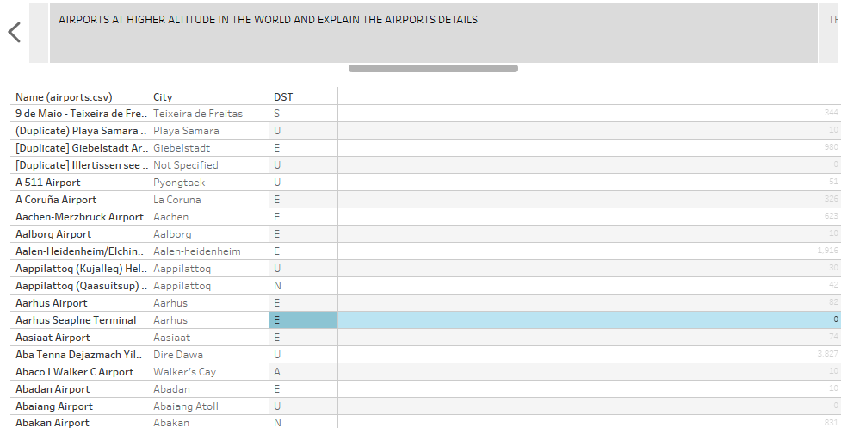

1. Revolution: A Dta Driven Exploration of Global of Air Transportation the Would.

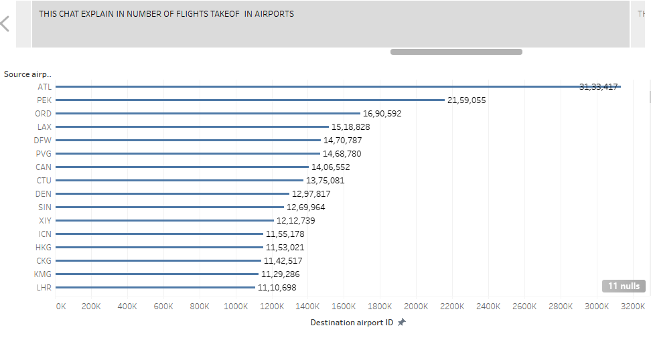

1. Revolution: A Data Driven Exploration of Global of Air Transportation.

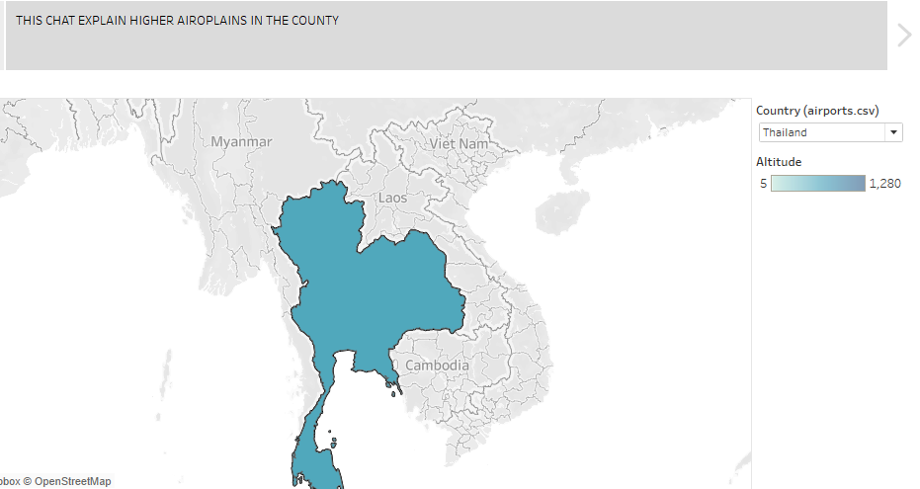

6.ADVANTAGES & DISADVANTAGES:

*Advantages:

* High Speed Air is the type of freight capable of travelling long distance in short periods of time
* Fast Service
* Send almost everywhere your freight
* High standard of security and natural route
* Risky and cost

*Disadvantages:

* Risky. Air travel is the riskiest mode of transport since there can be
* considerable losses to goods customer and crews as result of a minor crash
* Some product limitation
* Capacity for small carriage
* Enormous investment.

7. APPLICATION:

*The Various purpose,such as business and leisure travel,the delivery of time-sensitive goods,and emergency response and rescue missions.

1. CONCLUSION:

*As the intensity continuous to evolve,IATA Will remain an important player in shaping the future of air transport. Conclusion: The international Air Transport Association has been instrumental in developing and improving the air transport industry.

9. FUTURE SCOPE:

*Emerging technology ere reshaping with robotics,artificial intelligence,the internet of things,unmanned aircraft systems and the push for hybrid and electric airplanes.